| **Problem Statement : Online Bus Reservation System.** | | | | | | | | |
| --- | --- | --- | --- | --- | --- | --- | --- | --- |
|  |  |  |  |  |  |  |  |  |
|  |  |  |  |  |  |  |  |  |
| **What ? 1** | | | |  | **How ? 2** | | | |
| **1. What are the Functionalities or modules required ?**  **Ans : 1. Admin**  **a.) Add,Delete,Update the Bus,**  **Ans : Add Bus,Update timing bus info,routes,**  **Delete bus images,review,old info.**  **b.) Details and type of bus.**  **Ans: A/C,Non A/C,Sleeper,Seater,Semi-Sleaper,**  **Bus No,bus operator name and ph no.**  **c.) arrival ,departure and duration..**  **Ans : Timing and duration will be displayed**  **d.) view/ view all the bus details,**  **Ans : Live Location,Seats availability.**  **e.) Add/Delete/Update/view Faire Details,**  **Ans : Add or Update bus Fare according to the pickup**  **and drop location.**  **f. ) Add/Delete/update/view customer Details**  **Ans : View the details of the booked customer and**  **update it to the database.**  **g.) Approve / Reject refund.**  **Ans : Based on the scenario and the guidelines the**  **fund will be refunded.**  **2) User -**  **a)Register**  **What do the user need to register?**  **Ans:By providing personal details like phno,name**  **mobile no they can create an account.**  **b)Login**  **How to login?**  **Ans:By using username and password from**  **Account creation.**  **c) Search a bus.**  **Ans : Search a bus by name ,bus NO,pickup and**  **destination point,.**  **d) Book a bus.**  **Ans : Book a bus by**  **e)Cancel a bus.**  **f)Payment.**  **g)Review.**  **8)Travel History.** | | | |  | **1) Admin:**  **a) Add the Bus:**  **Method 1: Implement the Add Bus using Bus name.**  **Method 2: Implement the Add Bus using Bus no.**  **Method 3: Implement the Add Bus using individual Bus ID.**  **b) Delete / Update / View the Bus or fare:**  **Method 1: Implement the delete / view / update by using manually entering the**  **Bus id or name or no.**  **Method 2: Implement the delete / view / update by using the dropdown menu.**  **Method 3: Implement the delete / view / update by listing the all the bus details**  **and give an individual delete button for each.**  **c) Add the Customer:**  **Method 1: Implement using customer username.**  **Method 2: Implement using customer Email.**  **Method 3: Implement using customer Mobile no.**  **d) Delete / Update / View the Customer:**  **Method 1: Implement the delete / view / update by using email id**  **Method 2: Implement the delete / view / update by using username.**  **Method 3: Implement the delete / view / update by using mobile no.**  **2) User:**  **a) Registration / Login:**  **Method 1: Implementation using the username.**  **Method 2: Implementation using the username / email id.**  **Method 3: Implementation using the username/ email id/ mobile no.**  **b) Search a Bus:**  **Method 1: Implement the search of Bus using the Bus route.**  **Method 2: Implement the search of Bus using the Bus name.**  **Method 3: Implement the search of Bus using the Bus no.**  **c) Book a Bus:**  **Method 1: Implement Book a bus using the seat availability.**  **Method 2: Implement Book a bus using seat availability / price.**  **Method 3: Implement Book a bus using seat / price / travel time.**  **d) Cancel a Bus:**  **Method 1: Implement cancel of bus using the ticket no.**  **Method 2: Implement cancel of bus using PNR no.**  **Method 3: Implement cancel of bus using customer care call.**  **e) Payment:**  **Method 1: Implement payment option using upi.**  **Method 2: implement payment option using upi / internet banking.**  **Method 3: Implement payment option using upi / internet banking / bank transfer.**  **f) Review:**  **Method 1: Implement review using stars.**  **Method 2: Implement review using stars / comments.**  **Method 3: Implement review using stars / comments / video.**  **g) Travel History**  **Method 1: Implement travel history of past travel.**  **Method 2: Implement travel history of upcoming travel.**  **Method 3: Implement travel history of both past and upcoming travel.** | | | |
|
|
|
|
|
|
|
|
|
|
|
|
|
|
|
|
|
|
|
|
|
|
|
|
|
|
|
|
|
|
|
|
|
|  | | | |  | | | |
| **1) Admin:**  **a) Add the Bus:**  **Method 3: Implement the Add Bus using individual Bus ID.**  **Because Each bus has individual id, so searching process will be easy**  **b) Delete / Update / View the Bus:**  **Method 3: Implement the delete / view / update by listing the all the bus**  **details and give individual delete buttons for each.**  **Because admin can view each and every detail of the bus and do what operations**  **they want.**  **c)Add the Customer:**  **Method 3: Implement using customer Mobile no.**  **It will be easy to contact the customer.**  **d)Delete / Update / View the Customer:**  **Method 1: Implement the delete / view / update by using customer ticket number**  **Each booked customer will have a unique ticket number,it will avoid confusion.**  **2) User:**  **a) Register/login:**  **Method 1: Users can register using their phone number and login with it.**  **It will be easy to get contact with bus operator and to receive OTP.**  **b) Search a bus:**  **Method 2: Users can search the particular bus using their destination.**  **It will avoid confusion from selecting some other buses.**  **c) Book a bus:**  **Method 3: User can book a bus based on the ticket fare/travel timing/**  **feasible seat**  **Because this was fully based on user,they can select their bus**  **without confusion.**  **d) Cancel a bus:**  **Method 1: User can cancel the ticket using the ticket number.**  **It helps the admin to find the customer uniquely.**  **e)Payment.**  **Method : 3 Users can pay through both UPI and Netbanking.**  **User can pay with their preferable payment method.** | | | | **1) To add the Bus it is not feasible to implement using bus name or no. because for**  **the specific route of the buses has a similar name and no.**  **2) To delete the Bus details it is not feasible to delete using manually, because while**  **entering incase of mistakenly type one digit wrong then wrong bus details will be deleted.**  **3) To implement the customer details with name and email means sometimes their will be**  **similar names it is difficult to track the particular user.**  **4) Registration with only one type is not feasible for everyone to use the system.**  **5) Most of the Bus have similar names based on the specific route so it is not feasible.**  **6) While booking user can expect the seat availability and price range and travel time**  **so that they will book a ticket without any confusion. But specifying only one thing is**  **not feasible.**  **7) Cancellation of bus tickets is done by customer care and ticket no is not feasible. with**  **with the help of PNR no user is able to cancel the ticket in the system itself.**  **8) Implementing only one type of payment is not applicable.**  **9) While coming to single type of review user will lost the interest on giving the review,**  **Having multiple option for reviews can enable the user to give reviews.** | | | |
|
|
|
|
|
|
|
|
|
| **Why ? 3** | | | |  | **Why Not ? 4** | | | |

**Algorithm :**

**Admin point of view :**

**Step -1 :** Start.

**Step - 2 :** Enter into the Admin panel.

**Step - 3 :** Admin can add bus by clicking add button and Enter the bus details and a unique bus id will be generated.

**Step - 4 :** Admin can update the bus details by searching the bus using its ID and it will display all the details of the bus.

**Step - 4.1 :** Admin can edit all the fields except the ID .

**Step - 4.2 :** After editing click on done to save the changes.

**Step - 5 :** Admin can delete the bus by searing the bus using its id and click on delete.

**Step - 6 :** Admin can view the bus details by searching the bus using its ID.

**Step 7:** Admin can send the details to the customer (user) like bus Details,driver name ,live location and phone number etc .

**Step - 8 :** if the user requests to cancel the bus admin cancel the bus booking and refund Will be returned to the user based on the policies.

**Step - 9 :** Stop.

**User point of View :**

**Step - 1 :** Start.

**Step - 2 :** enter into the login page.

**Step - 3 :** if you are a new user go to the register page.

**Step - 4 :** if you are an existing user fill the login credentials.

**Step - 5 :** enter into the home page .

**Step - 6 :** for bus booking search a particular bus using their destination .

**Step - 7 :** filter the bus search using bus price,travel timing and feasible seats.

**Step - 8 :** user can pay through both upi and card

**Step - 9 :** for cancellation of bus user can cancel the bus using ticket number before 1 hour of arrival time

**Step - 10 :** user can give rating to the bus and app

**Step - 11 :** Stop.

**Flow Chart :**

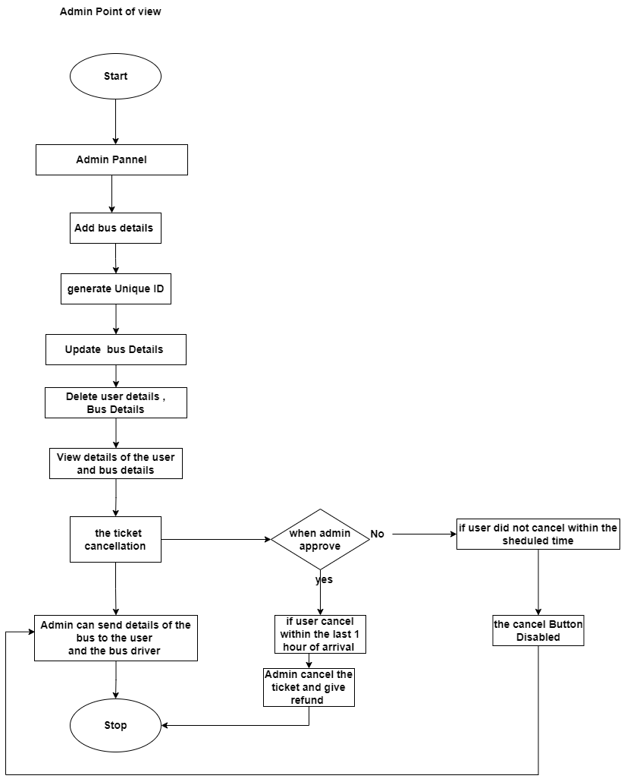

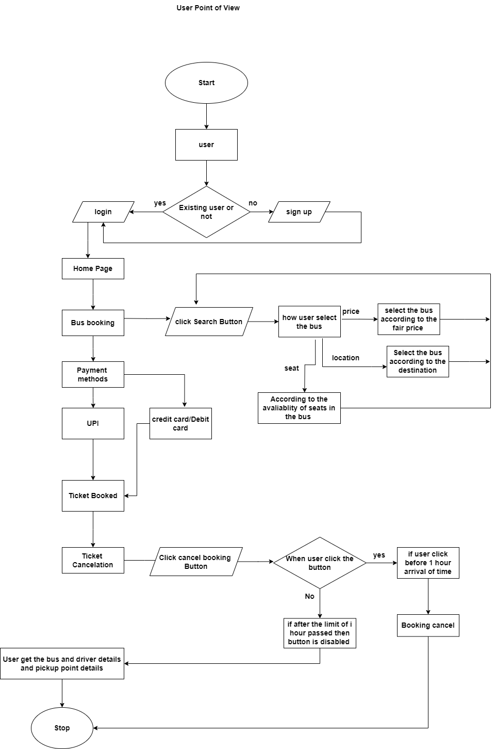

***UML***

***Admin :***

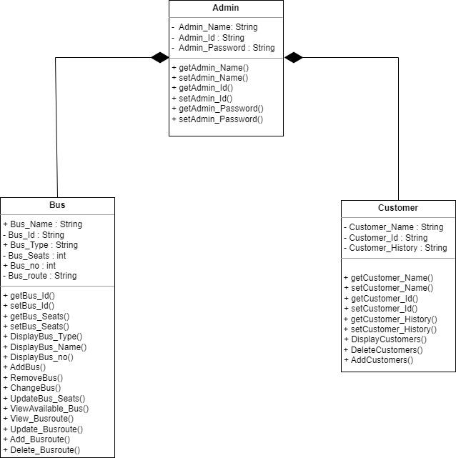

***User:***

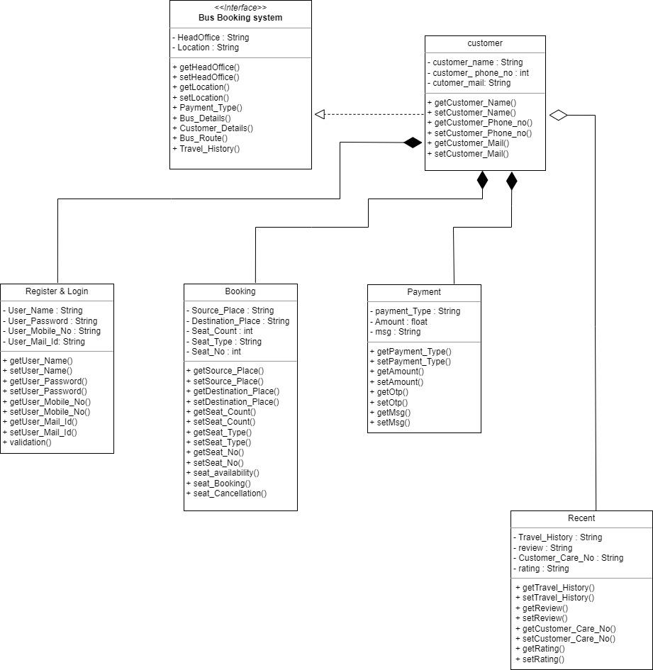

***UseCase Diagram:***

***Admin:***

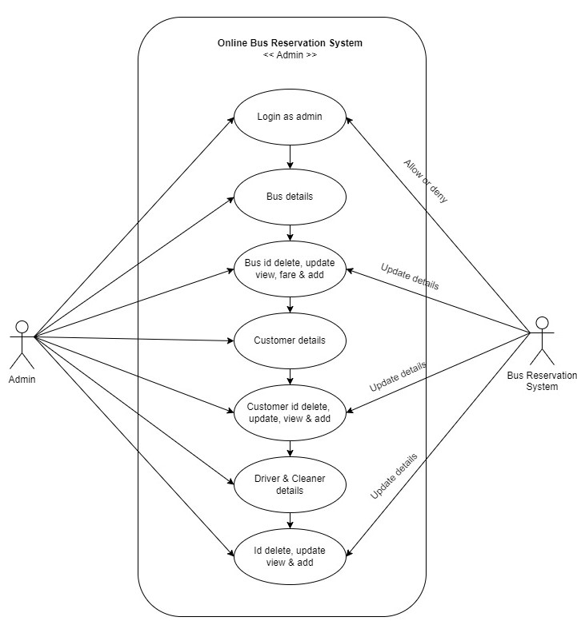

***User : 1***

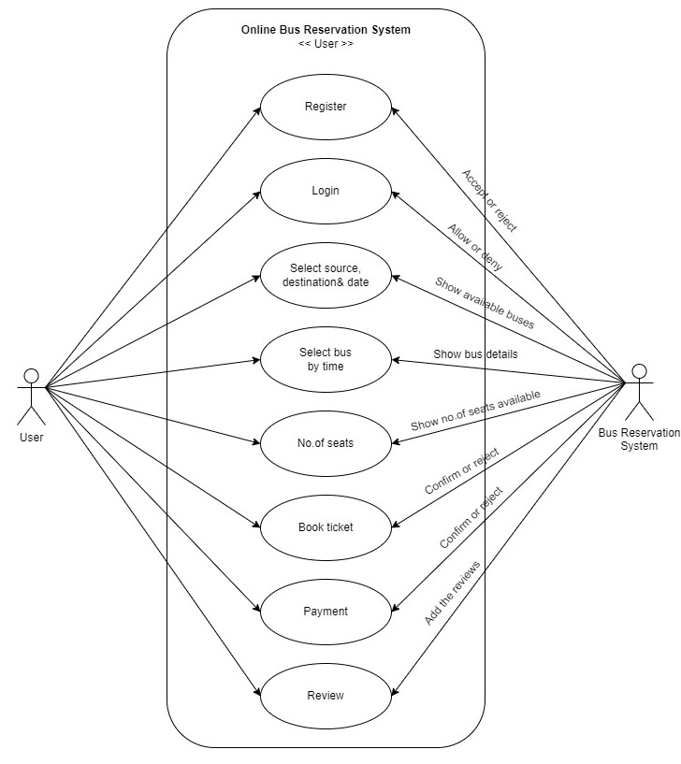

***Sequence Diagram :***

***Register & Login***

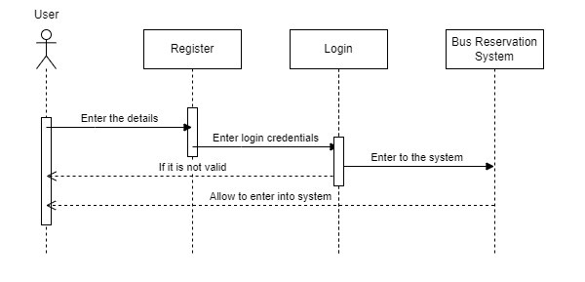

***Bus Fare :***

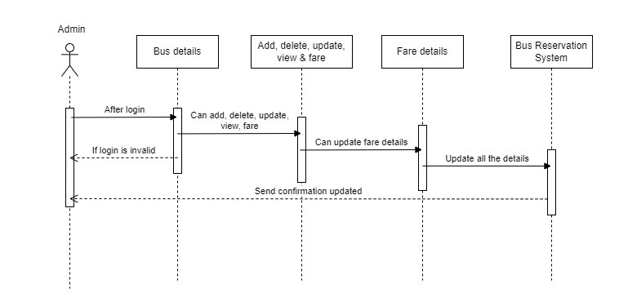

***Customer Details :***

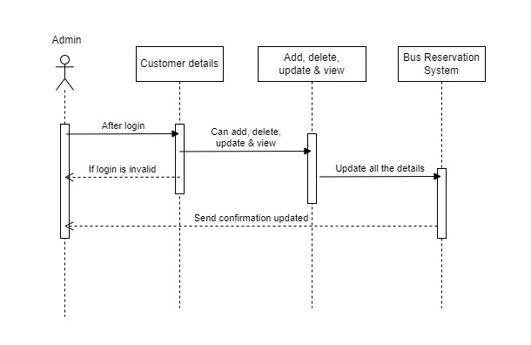

***Driver & Cleaner Details :***

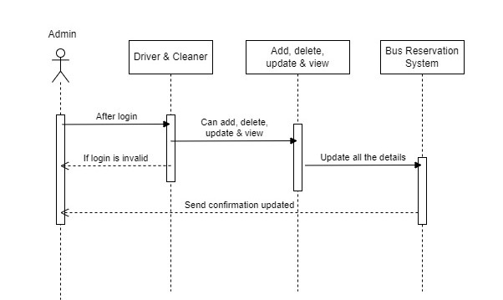

***Booking :***

